**About UPRAiZAL Information**

About UPRAiZAL information feature provides details about the current UPRAiZAL application related Version, Type, License Validity details

**Version: 1.0**

**Date: 29-Oct-2020**

*All rights reserved. No part of this publication may be reproduced, transcribed, transmitted, stored in a retrieval system or translated into any language, in any form or by any means mechanical, manual, electronic, magnetic, chemical, optical, including photocopying or otherwise without the prior written permission of UPRAiZAL, Inc.*

Contents

Revision History 2

Requirement 3

Implementation Method 3

Code Modifications 3

List of required Jars & File Paths 5

Use cases (Must for Unit Test) 5

Screen Shots 5

# Revision History

|  |  |  |  |
| --- | --- | --- | --- |
| Version | Author | Date | Description |
| 1.0 | HYD0176SD | 06/APR/2021 | Initial Version |
|  |  |  |  |

**Confidentiality**

The contents of this document are considered confidential and proprietary information of UPRAiZAL, Inc. No part of this document may be reproduced, fully or in part, or divulged to any other party without prior written permission from UPRAiZAL, Inc. All logos of respective owner companies used in this presentation are recognized.

# Requirement

New menu item namely “About” should be added under Help Navigation menu.

On click of About menu, pop up should come and show below mentioned UPRAiZAL application details.

1.Version (Current UPRAiZAL version)

2.Type (It might be Professional or Enterprise)

3. License Validity (License Expiry Date)

Note: Expiry Date should not display for User and Trainee Roles.

# Implementation Method

To accomplish this requirement, followed below approach

**Java and UI:**

**UI**: Added “About” link in the Help section.

**UI:** Whenever user clicks on “About”, displaying popup with current UPRAiZAL information.

**Java:** Written a service which provides Current UPRAiZAL information.

# Code Modifications

**File Path**

--b_22_03_2021_UPRAiZAL_Avante _1.4_Dev\upraizal-web\src\main\webapp\WEB-INF\tiles\page-header.jsp

**Purpose**

* Added “About” link and corresponding implementation.

**Modifications**

Implementation of “About Link

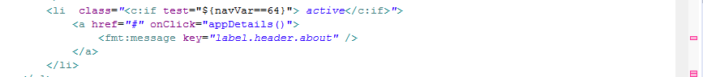

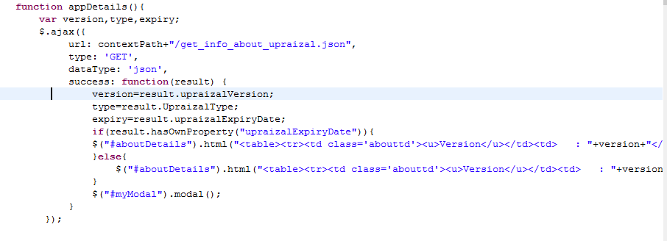

Implementation for ‘UPRAiZAL Information’ Popup window

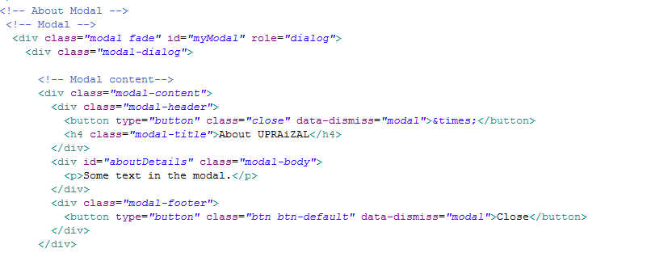

**File Path**

--b_22_03_2021_UPRAiZAL_Avante _1.4_Dev\emp\src\main\java\com\defteam\emp\controller\EmpController.java"

**Purpose**

* Implemented a service which collect the information about current UPRAiZAL system.

**Modifications**

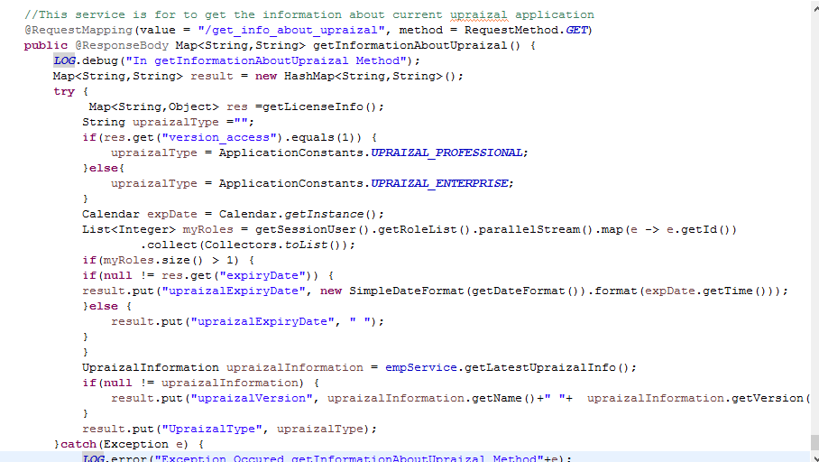

# List of required Jars & File Paths

b_22_03_2021_UPRAiZAL_Avante _1.4_Dev\emp\src\main\java\com\defteam\emp\controller\EmpController.java

--b_22_03_2021_UPRAiZAL_Avante _1.4_Dev\upraizal-web\src\main\webapp\WEB-INF\tiles\page-header.jsp

# Use cases (Must for Unit Test)

1. In the UI able to find ‘About’ link inside of Help section.

2. For Role User and Trainee, License Validity should not display.

3. Popup should always display the details as per the latest deployed UPRAiZAL application in that instance.

# Screen Shots

About Link Screen:

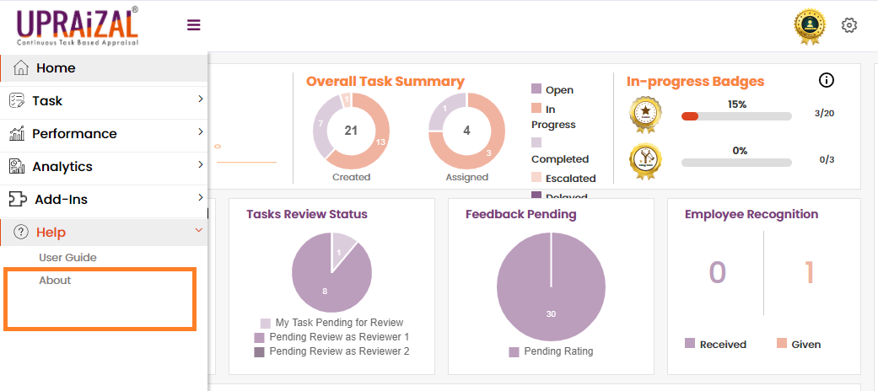

About UPRAiZAL Pop up screen:

